**Lab7 Submission**

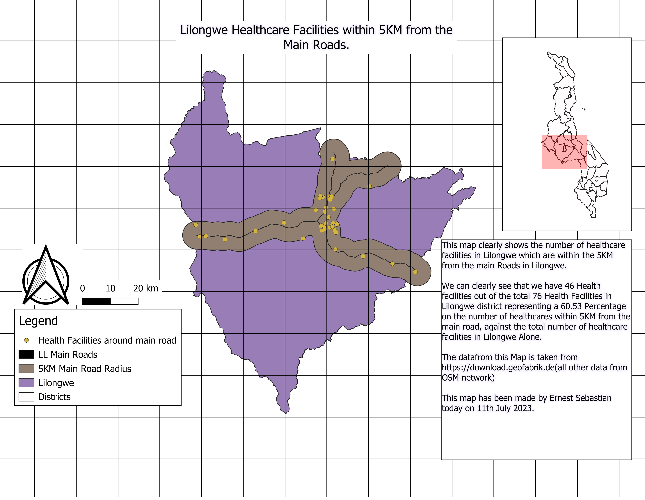

**Questions**

Total number of healthcare facilities in Lilongwe District: **76**

Total number of healthcare facilities within 5-km highway buffer zone in Lilongwe District: **46**

Percentage of healthcare facilities in Lilongwe District that are within 5-km zone: **60.53**

**Reflection**

Upon examining the map, we discovered that there is a higher number of health facilities along the main roads compared to areas farther than 5 kilometers away. This finding suggests a few things, such as easier access, transportation convenience, and more people living near the main roads.

However, it is concerning that this difference is quite significant, with 60 percent more health facilities on main roads. This means that the most remote parts of Lilongwe, the capital city of Malawi, lack proper access to healthcare services. This poses a major health risk to the people living in those areas.

To address this issue, it is important to ensure a more balanced distribution of health facilities across different locations in Lilongwe. By doing so, everyone in the city, regardless of where they live, will have better access to healthcare services. This will greatly benefit the people of Lilongwe as the capital city of Malawi.